To the Swedish government: Journalism is not tourism

To the Ethiopian government: Journalism is not terrorism

To both governments: Johan Persson and Martin Schibbye should be set free immediately

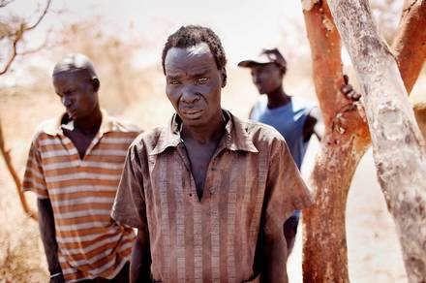

His family was murdered: Ruei Bawar Jieth’s family was murdered in the autumn of 1997 when the Sudanese army was making a road for Lundin Oil. *Photo: Magnus Wennman*

**What were the imprisoned Swedish journalists Johan Persson and Martin Schibbye trying to look into Ethiopia?**

Over the next few days we will be answering this question. But first, some background.

**Summer 2010**: Public prosecutor Magnus Elving initiates a preliminary criminal investigation into violations of international law. The suspect: the Swedish stock exchange-listed oil company Lundin Petroleum.

This is in the middle of the election campaign. Swedish Foreign Minister Carl Bildt is a former board member of the company. Nevertheless, by and large, silence rules in the Swedish media about the preliminary investigation.

**Summer 2011:** Johan Persson and Martin Schibbye are seized in Ethiopia on suspicion of terrorism. Sweden’s Foreign Minister says:

“This is of course an area that we have advised people against travelling to, because it is a dangerous place.”

It sounded as if Carl Bildt was comparing journalism with tourism.

Johan Persson and Martin Schibbye did not enter Ogaden in Ethiopia for sun, warmth and relaxation.

They were seeking the truth about the involvement of Lundin Petroleum and Carl Bildt in a crime against international law.

The international oil market is literally a powder keg and moral swamp, with very few areas of firm ground on which to stand. Lundin Petroleum’s daring strategy in the worst possible areas has turned them into a high flyer on the Stockholm stock exchange, with billions of kronor in profits.

**But at what price?**

The answer will depend on the world view of the person you ask.

The price is 12,000 dead people, claim human rights organisations.

Drilling for oil in completely impoverished and politically wrecked areas creates peace and prosperity, claims Sweden’s Foreign Minister Carl Bildt.

The Swedish media have been criticised for their silence over the oil affairs and Bildt.

*Aftonbladet* intends over the next few days to respond to this criticism through a series of reports.

The freelance journalists Leo Lagercrantz and Jens Christian Brandt travelled together with *Aftonbladet*’s photographer Magnus Wennman to South Sudan to seek the truth about Lundin’s and Carl Bildt’s oil adventures in Sudan.

When the civil war was at its height between 1983 and 2005, Lundin Petroleum was operating here with the aid of the regime’s notoriously violent forces in the Sudanese marshlands.

Johan Persson and Martin Schibbye wanted to find out whether history had repeated itself in Ogaden in Ethiopia, just one hour’s flying time from South Sudan. Their reports can be read as an endorsement of their endeavours.

We have three clear messages with this publication:

* To the Swedish government: Journalism is not tourism
* To the Ethiopian government: Journalism is not terrorism
* To both governments: Johan Persson and Martin Schibbye should be set free immediately

Jan Helin

Aftonbladet, Friday 9 March 2012

*Original Swedish article:*

http://www.aftonbladet.se/nyheter/article14495653.ab