Bentiu, Juba/South sudan.

* In an office on Brigadgatan in Linköping all the evidence is piling up in the ongoing preliminary criminal investigation into the Swedish oil company Lundin Oil.
* Public prosecutor Magnus Elving has to reach a conclusion on reports of murder and ethnic cleansing in South Sudan.
* The question: Has Lundin Oil been guilty here of crimes under international law?
* Aftonbladet’s team of Leo Lager­crantz, Jens Christian Brandt and Magnus Wennman have returned to the site of the alleged crimes.
* In Unity State, South Sudan, we meet people whose lives were ruined when Lundin Oil moved in.

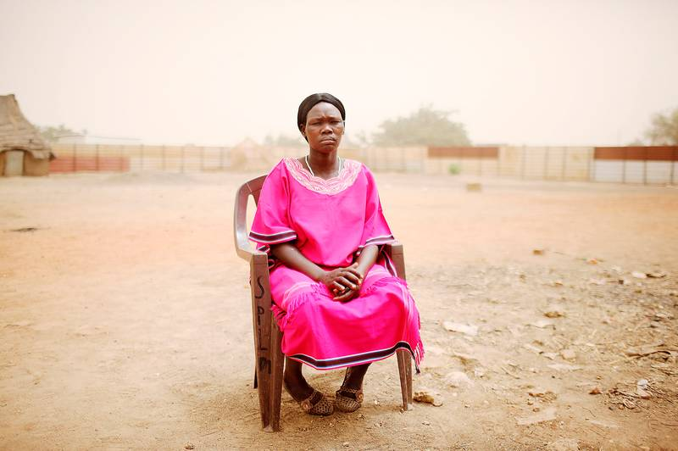

Raped for seven years: Katerina Choul Kor was taken as a sex slave when she was 14 year’s old. “We were more than 50 women in the same cell. All the time soldiers came and raped us,” she says. Katerina is the only one to return to her village. She is married – but because of the injuries from the rapes she will never have children. “ I dearly wanted to have children,” she says. Photo: magnus wennman

Wherever you go in Unity State you can see the traces. Of oil and the wars. Pipelines cut through the lion grass. Oil workers’ barack blocks crouch behind rusty fencing. The road is lined with shot-up military vehicles. This is Lundinland. It was here, to one of Africa’s most godforsaken spots, that the Swedish oil company Lundin Oil came in 1997. To look for black gold in Block 5 A – an area where the poverty above ground stands in sharp contrast to the riches below ground. From the aid-enriched bling-bling atmosphere of the capital Juba we have made our way up here to the lawless bush. Apart from the oilfields there only roadblocks here. Kalashnikovs and traumatised characters in camouflage uniform.

The first person we meet is a former guerrilla leader. Mabeak Lang was one of the local rebels who for 22 years fought against the government in Khartoum. And against the international oil companies, including the Swedish company Lundin Oil. Now he is sitting in the dust of the barracks yard in Pariang, where he is the local commander. “Send my best wishes to your compatriots,” he says. “We will get compensation. From Sweden. Both money and infrastructure. Lundin exploited us; now we want schools and hospitals.”

When we ask him to tell us the story, he sips his cinnamon tea and starts in 1979. That was when the oil giant Chevron arrived in the area. “Before that we scarcely knew what oil was. Then the Americans came and started to drill. To start with their were no problems. Nobody came to any harm, and there was no great encroachment on the environment.” The honeymoon was nevertheless short.

When the people of South Sudan realised that all of the income from the oil went to the government in the north, respect for Chevron turned into hatred. “Our guerrillas attacked their head office.”

That was the way the oil war started. A 22-year inferno of murder, expulsion and slave trading. Just during Lundin’s time: 12,000 dead and 160,000 people driven away. He emphasizes that the area Lundin Oil came to was a war zone. “Everything was chaos. The Sudanese army and the guerrillas fought one another. Our nomad tribes carried out raids and took women and children as slaves. And in the middle of the fighting: the company from your country.”

Mabeak does not believe for one second that Lundin Oil was ever neutral. “On the contrary, in order to be able to drill at all they needed the support of the army. Soldiers were sent in to drive away anyone who lived near the oilfields. Villages were burned, civilians were killed in droves.

Just here in Pariang 4,000 to 5,000 people were murdered.”

He also accuses Lundin of indirectly having supplied the regime with weapons. “Every cent that Sudan earned from oil was invested in military equipment. Suddenly the air force had attack helicopters from the Ukraine. They flew in over villages shooting until nothing moved.”

He is quite certain, he says, that it was oil company pilots who were at the controls. “One day they flew for Lundin, the next for Khartoum. They were not Arabs, but white men or Asians.”

In the thirty-five degree heat a woman in a pink dress walks across the barracks yard. Her name is Katerina Choul Kor. Of all the women taken as sex slaves during the oil wars she is the only one to return home. “I was 14 years old when the army attacked my village. They took 200 women in a single night.” Her voice is just a whisper.

“We were more than 50 women in the same cell. Naked, without food, without toilets. All the time soldiers came and raped us.” It went on for seven years. In a prison in Northern Sudan. The result: a life ruined. “I really wanted to have children. But it is not possible.”

We get into the car and drive through the war-torn landscape. More road blocks, more burned-out cars along the road. More witnesses to Lundin Oil’s involvement in the oil war. Out in the deserted steppe lies the remains of Ding Yien. Once it was a vibrant village with huts, farming and cattle.

“Now there’s just us left, “ says Ruei ­Bawar Jieth, pointing to the men standing next to him.

He tells us that his family has lived here for generations. Without the faintest notion about the oil and what it was worth. “Then the soldiers came. They marched in here and demanded that we leave the village. It was in 1997. When we refused, they set fire to the huts. They stole our animals and took the women and children prisoner. All the men were shot dead. They killed my mother and father and my brothers. I escaped out into the swamp.”

In the capital Juba sit rappers Lam Tungwar and Emmanuel Jal. They are world famous in Sudan.

Their rhythmical afro-hiphop is a cult throughout the East African metropolises. Lam made the soundtrack for the notweworthy film “Blood Diamond”. And Jal is the man behind the successful song “War Child”. But, just like the town outside the dusty windows, they have a fractured past history.

“When I was seven years old, I became a child soldier,” says Lam, adjusting his Armani tie. He comes from Bentiu, in the oil district. He remembers that as a little boy he was happy. And proud of his father, who was a chief. “When the oil war broke out, I became separated from my parents and ended up with a guerrilla group. I was alone and afraid, but they promised me that everything would be all right if I agreed to fight with them. What makes me sick is that you are so proud when you are given a gun. You understand, I was seven and had my own Kalashnikov.“

His friend Emmanuel Jal, who was also a child soldier, says that the oil companies stole their youth.

“We were so small. And we thought the war was normal, that it was normal to kill people.

It was only later that I understood that everything was the fault of the oil.” “Yeah,” says Lam, “Without the oil, no war.”

The people we meet are reliable witnesses. They know what they have experienced. They have seen their loved ones murdered. At night they still have nightmares about attack helicopters and burning villages. So far they have not been able to tell their story to prosecutor Magnus Elving. But if he decides to bring in an indictment for crimes against international law then maybe some of the people we met will testify against the powerful oil company. Then their words will be weighed against those of Carl Bildt.

By: Leo Lagercrantz, Jens Christian Brandt

Aftonbladet, Friday, 9 March 2012

Original Swedish article: <http://www.aftonbladet.se/nyheter/article14495695.ab>